Program 10: Demonstrate data replication across regions using S3 Services in an experiment
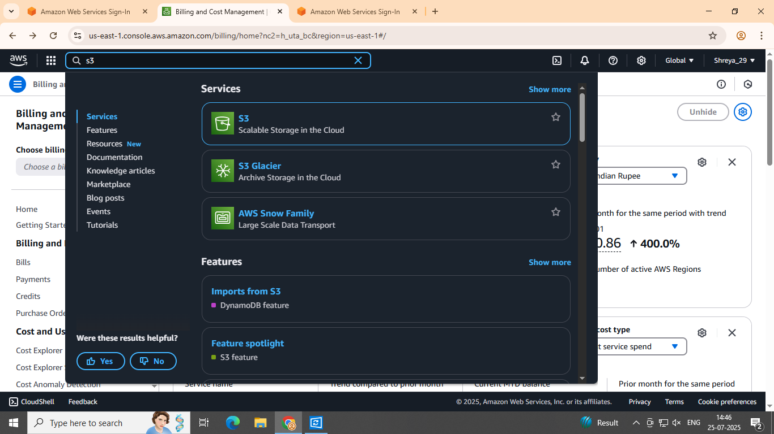
Step 1: Sign in to your AWS account and select "S3" from the list of services.
Step 2: Create Source Bucket Navigate to S3 from the AWS services.
  - Click Create bucket.
  - Name the bucket, e.g., source-bucket-replication.
  - Select the region you want to use for the source bucket (e.g., us-east-1).
  - Disable Block all public access (if needed for testing, though generally, it should remain enabled).
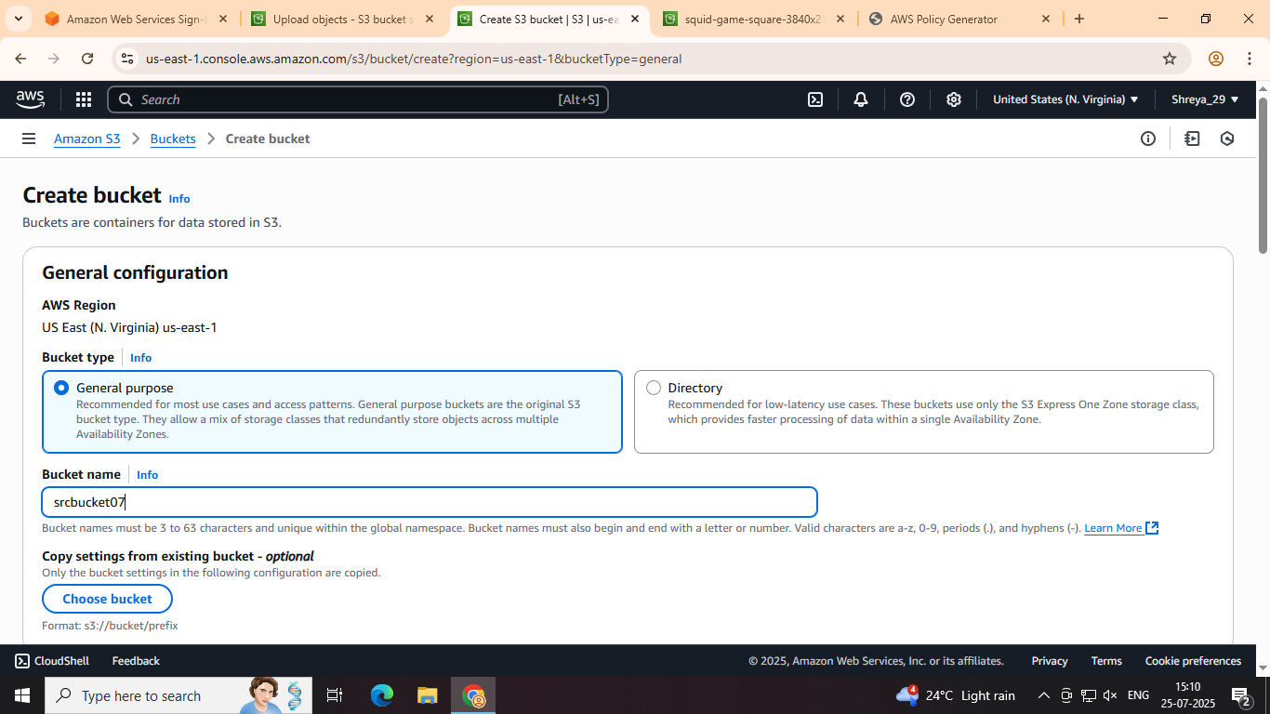
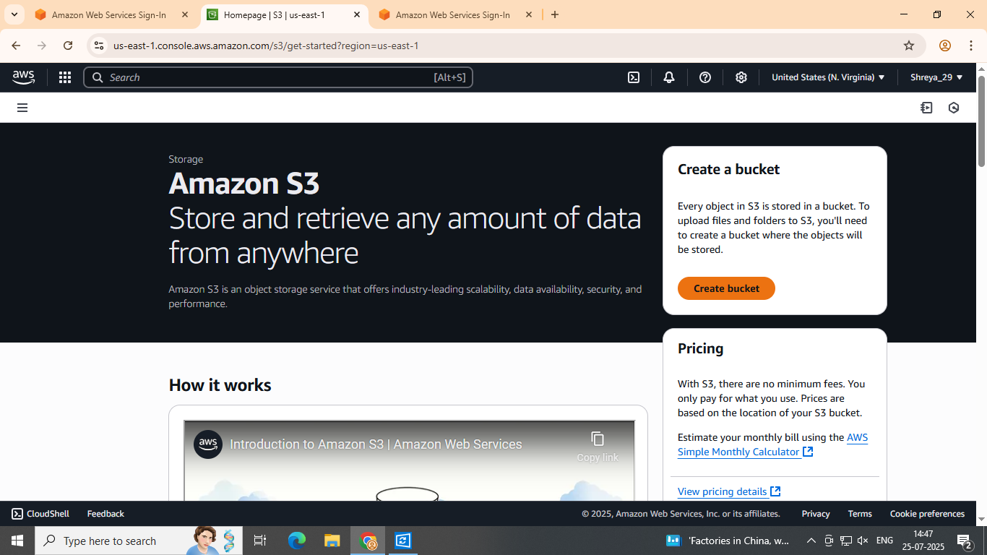
  - Leave other settings as default and click Create bucket.
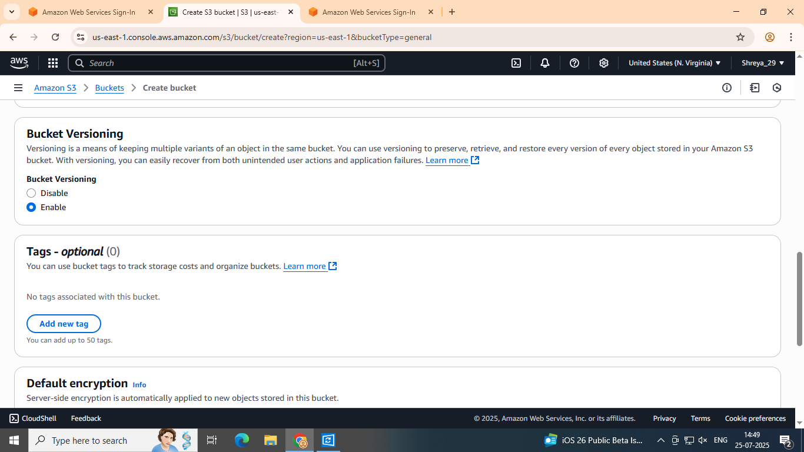
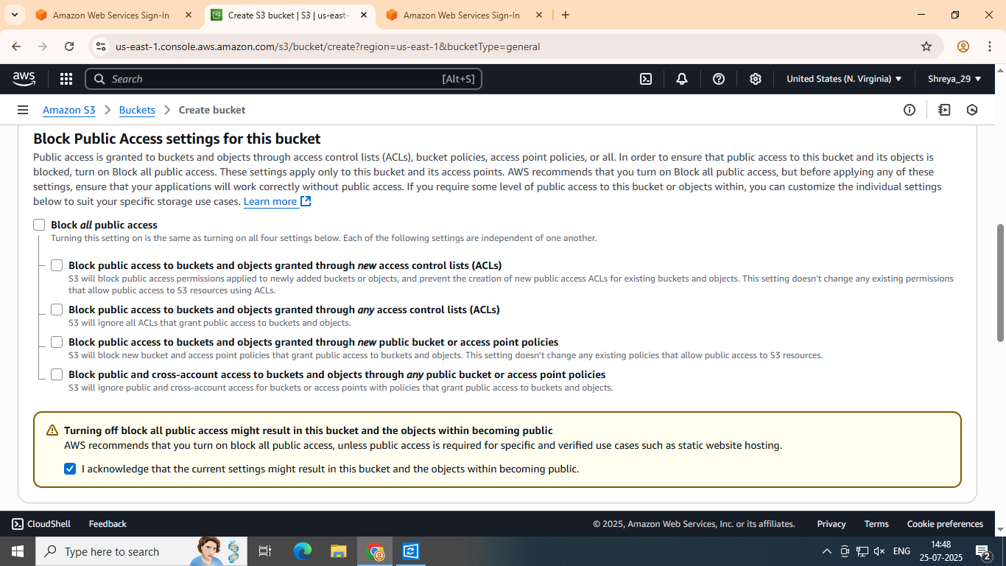
Step 3: Create the Destination S3 Bucket:
  - Repeat the same process to create another bucket (e.g., destination-bucket-replication) in a different region (e.g., eu-west-1).
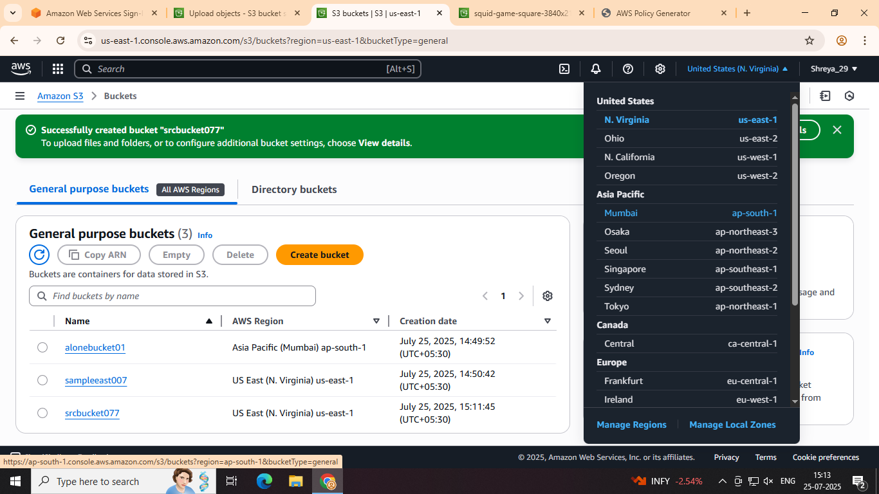
Note: The destination bucket must be in a different region from the source bucket for CRR to work.
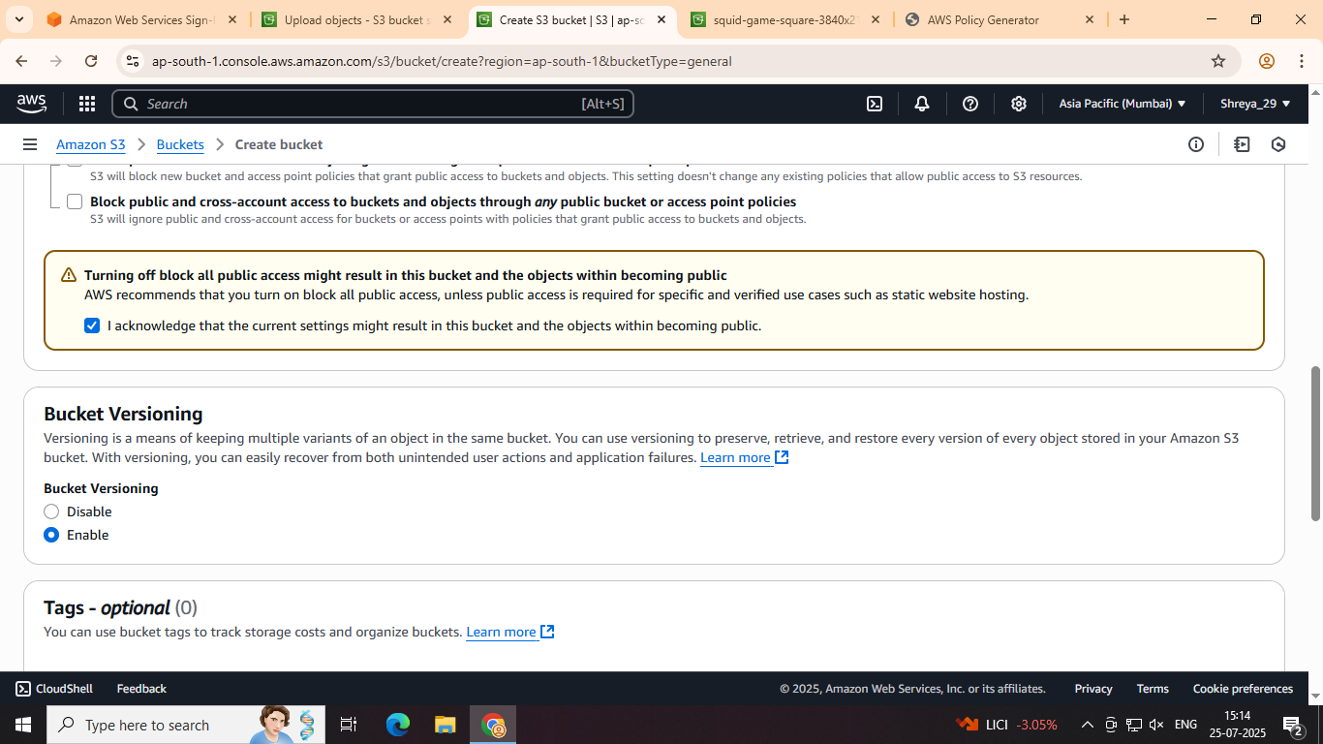
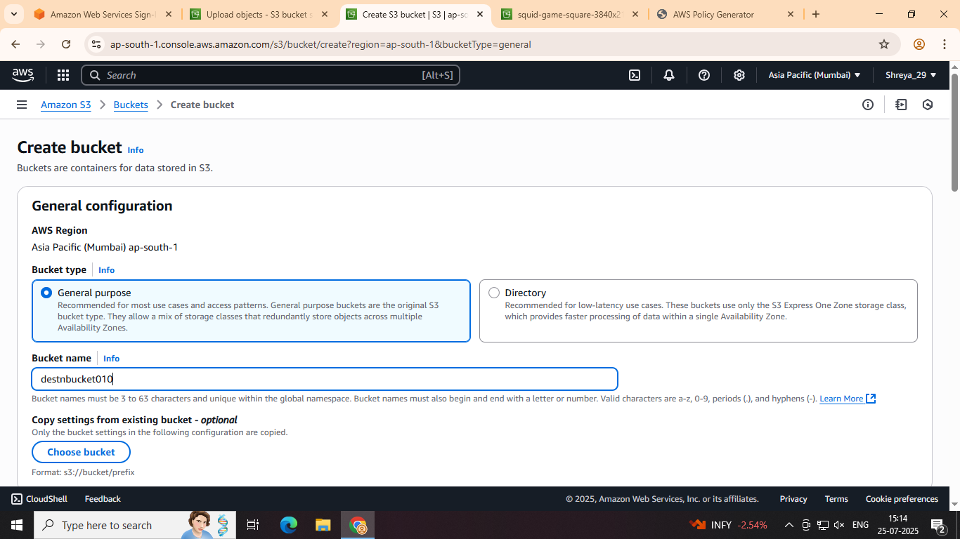
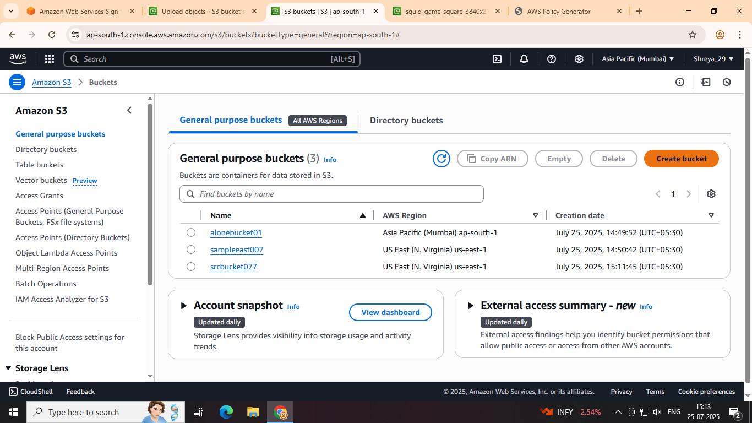
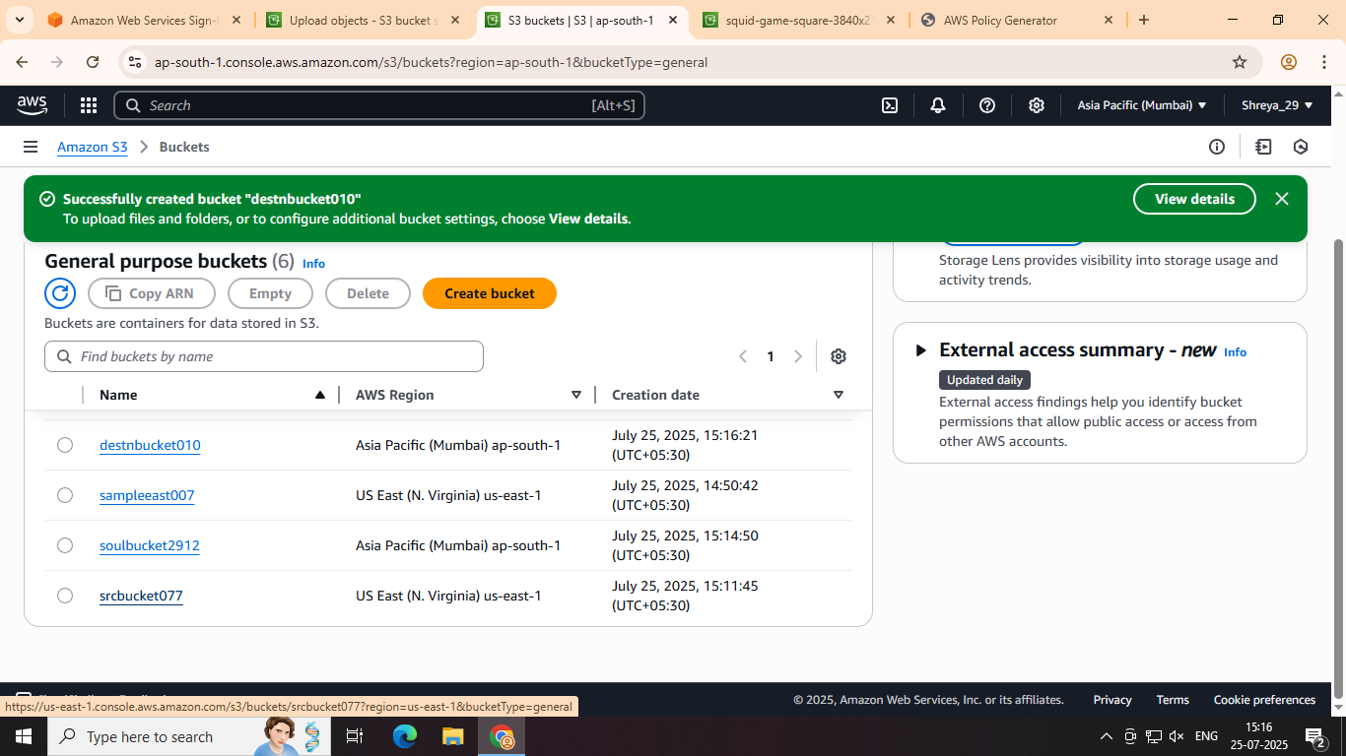
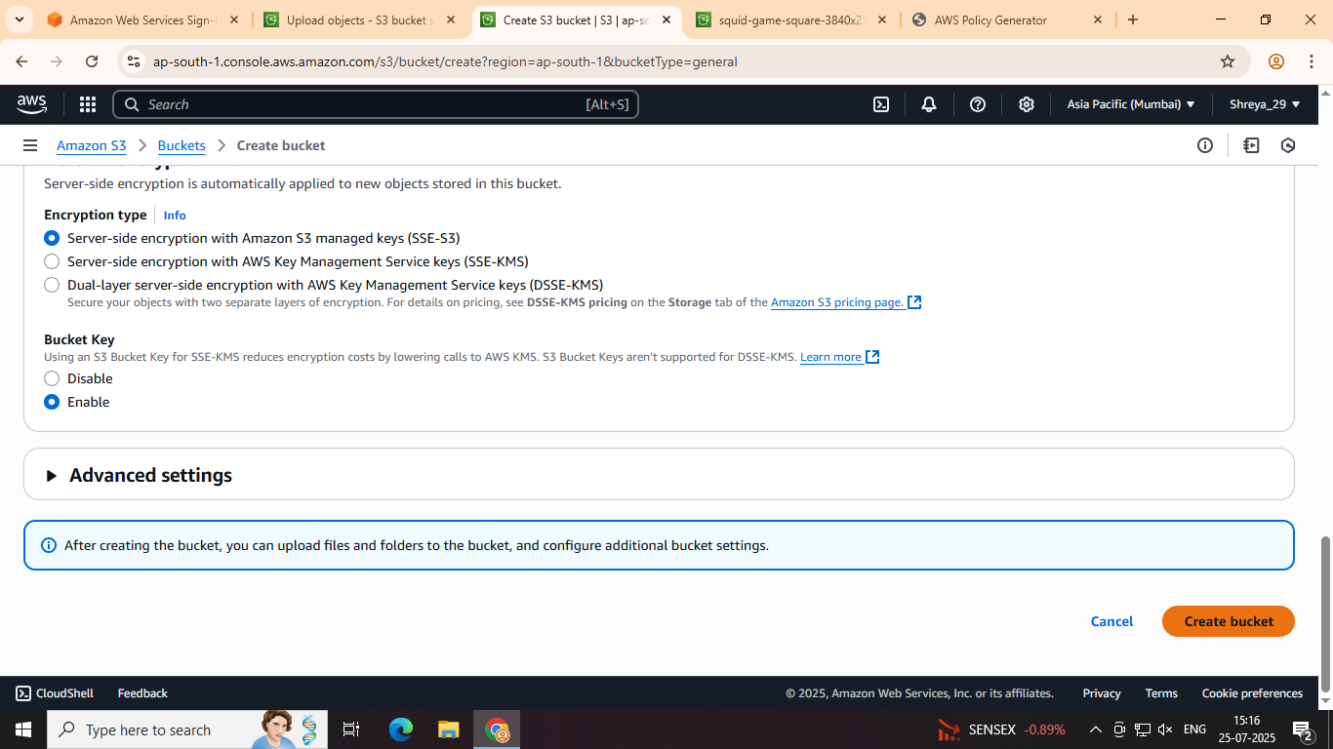
Step 3: Configure Cross-Region Replication (CRR)
- Go to Source Bucket (Replication Settings):
  - In the S3 console, go to your source bucket.
  - Go to the Management tab.
  - Scroll to Replication rules and click Create replication rule.

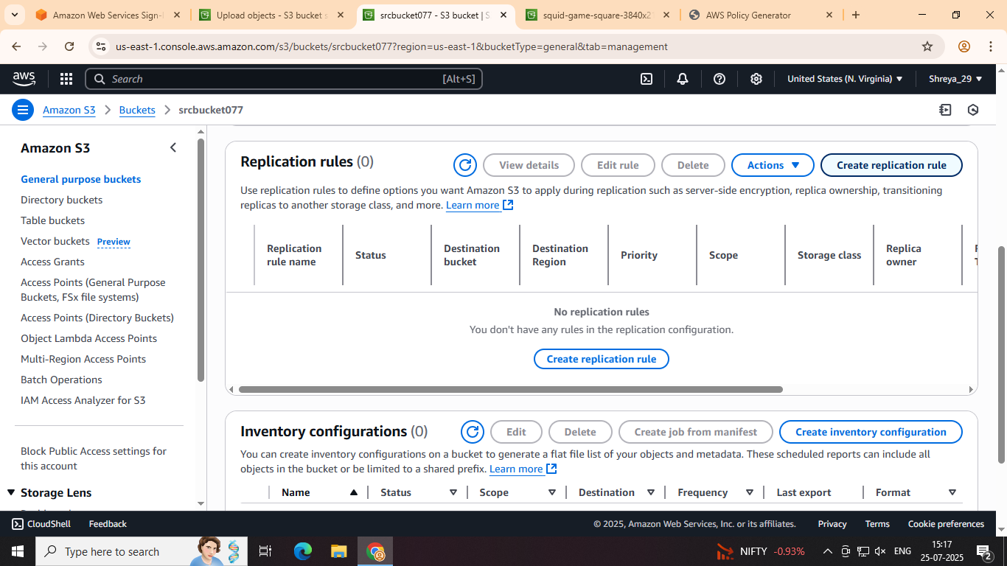
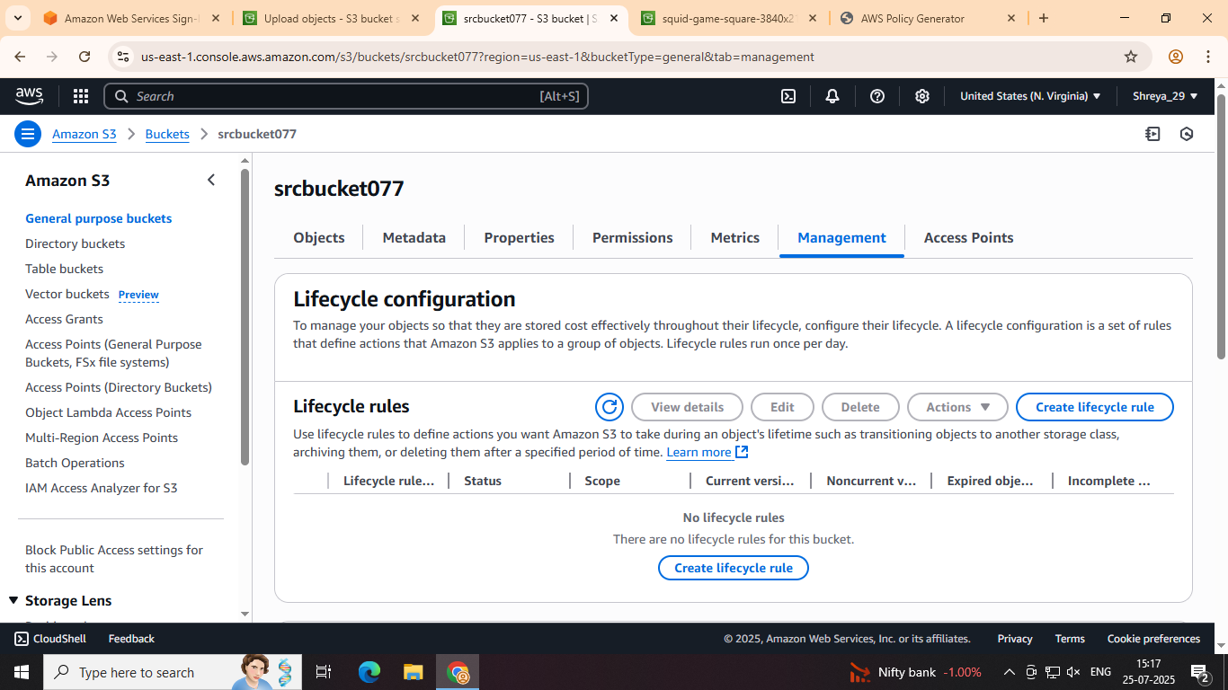
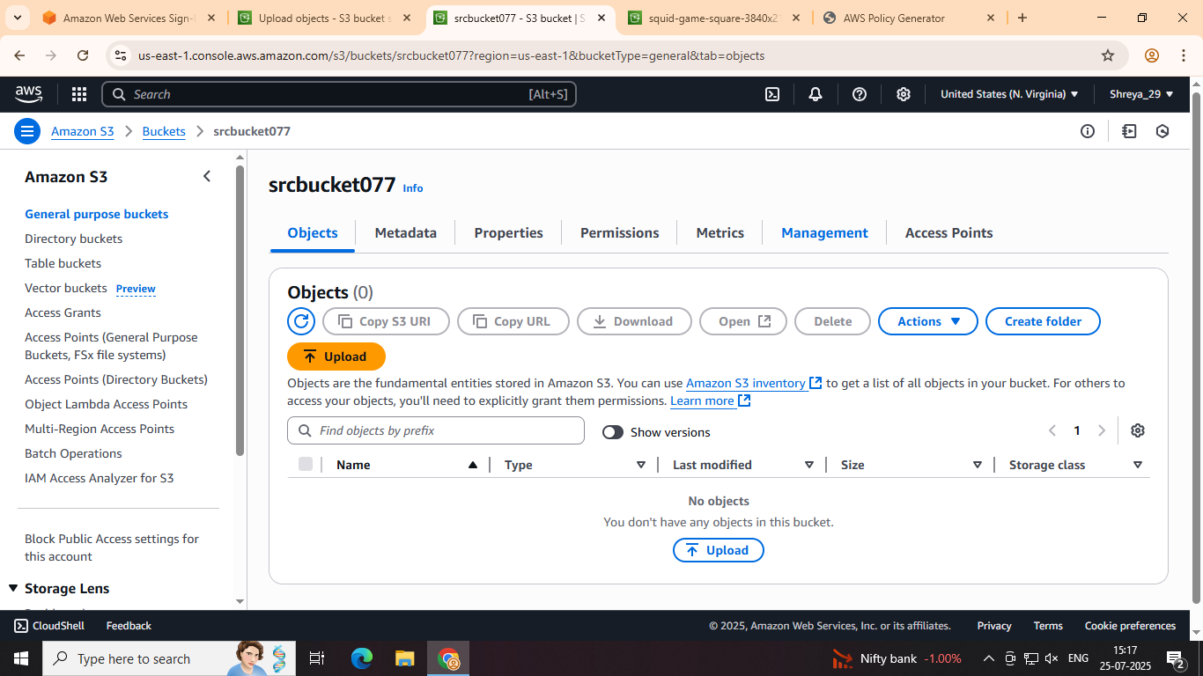

- Create Replication Rule:
  - Rule name: Give your rule a descriptive name (e.g., CRR-Rule-Source-to-Destination).
  - Source bucket: Select whether you want to replicate the entire bucket within the bucket.
  - Choose to Apply to all objects in the bucket (for this experiment).
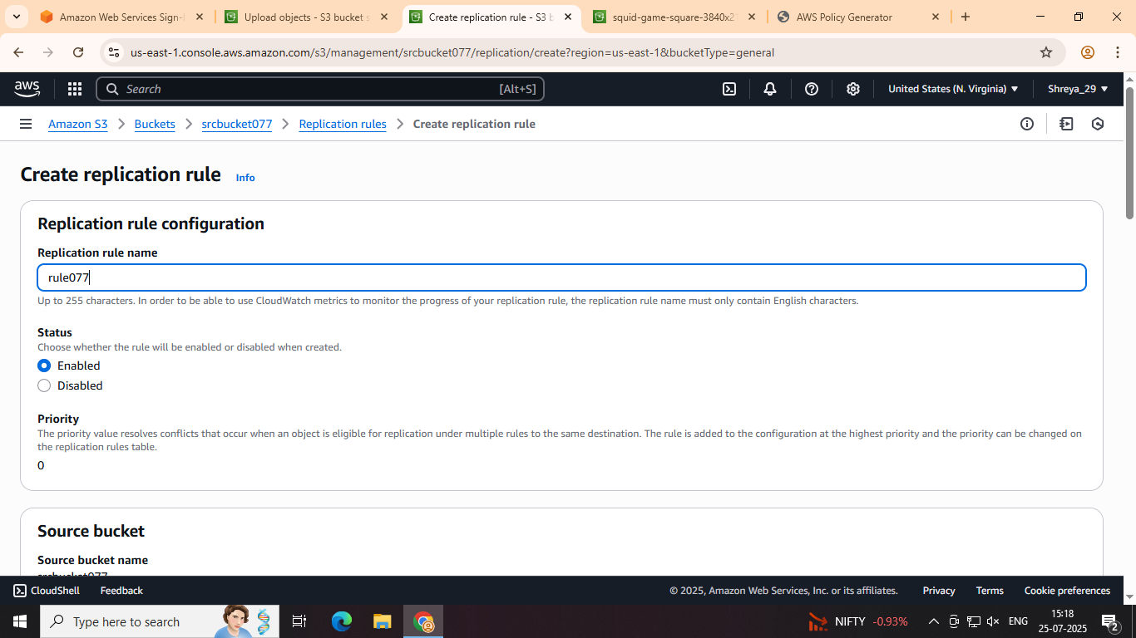

  - Destination bucket: Select the destination bucket you created earlier (destination-bucket-replication) and its corresponding region.
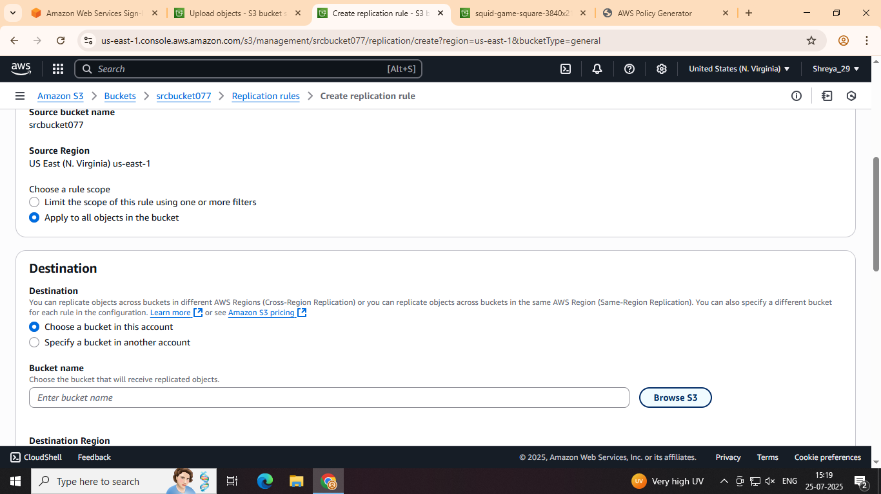
- Choose Destination Options:
- Permissions for Replication:
  - AWS will ask you to set up a role to allow S3 to replicate objects from the source bucket to the destination bucket. Choose Create a new role.
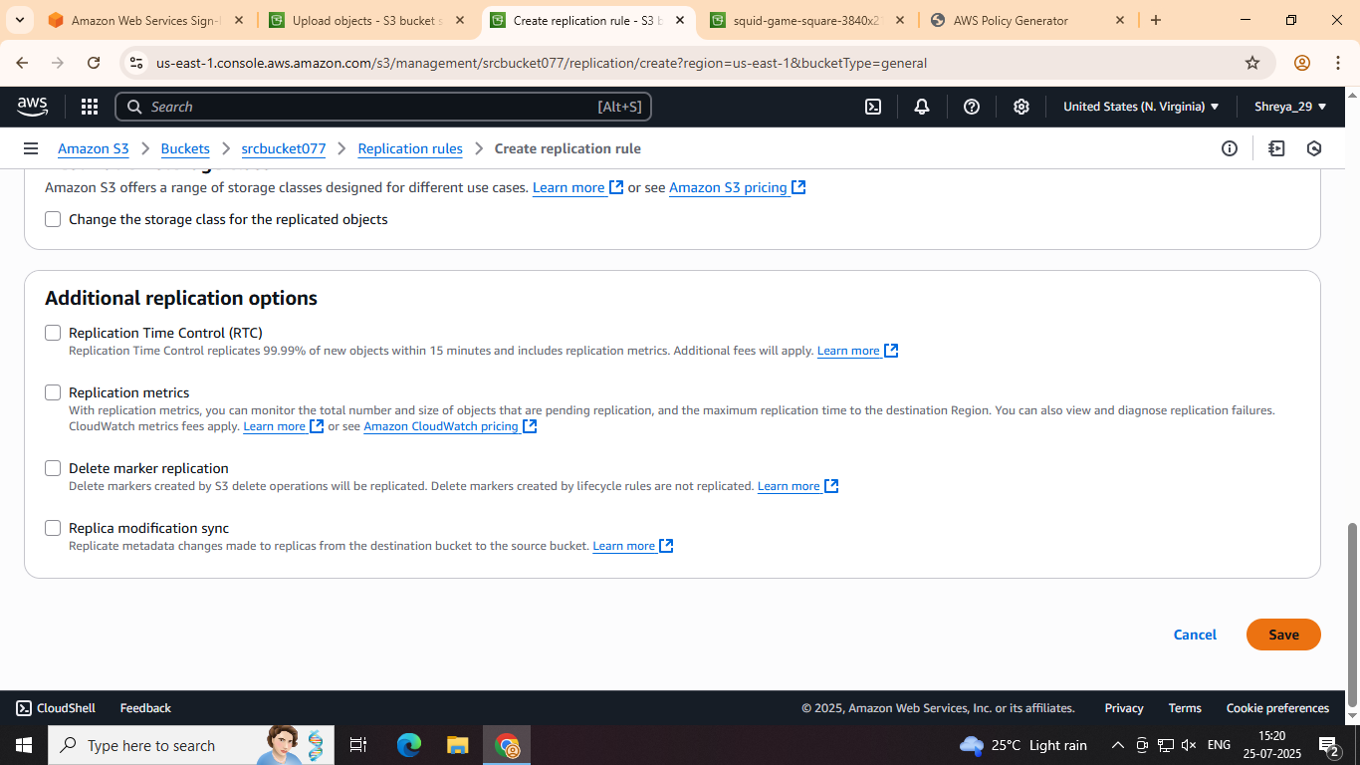
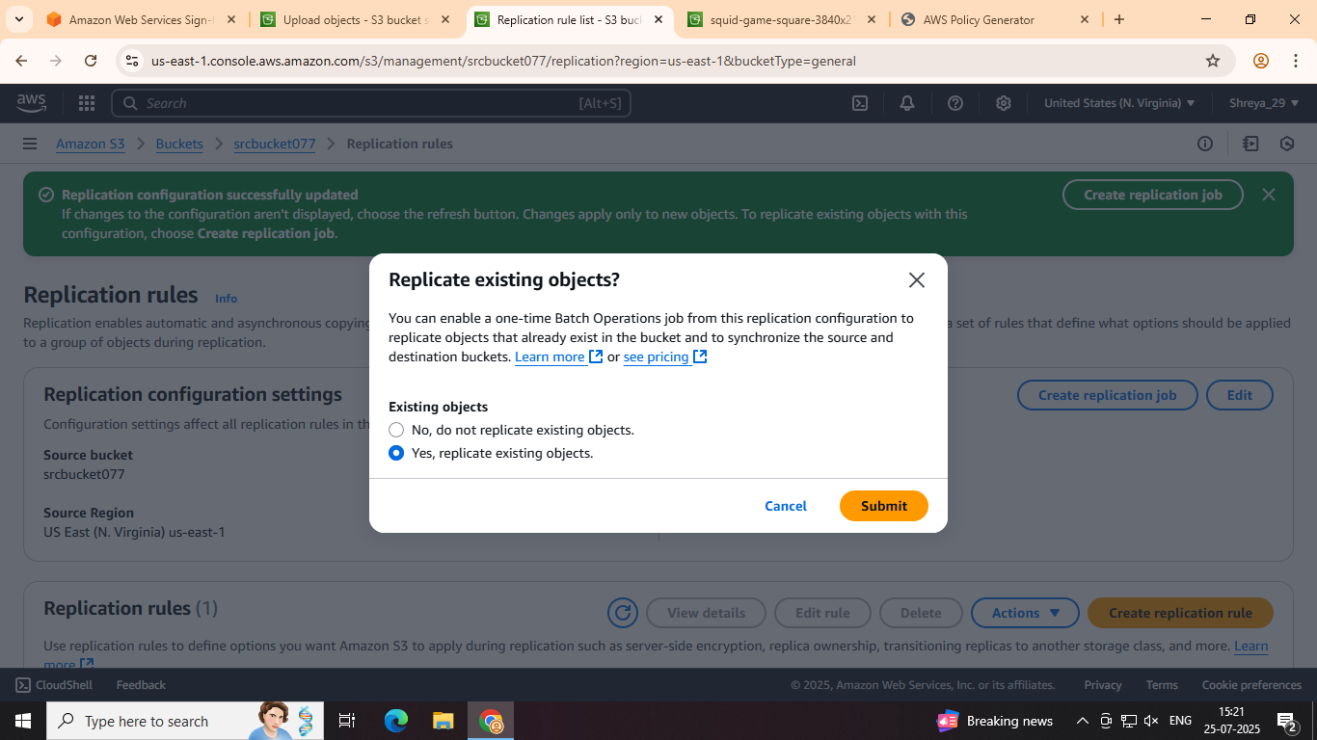
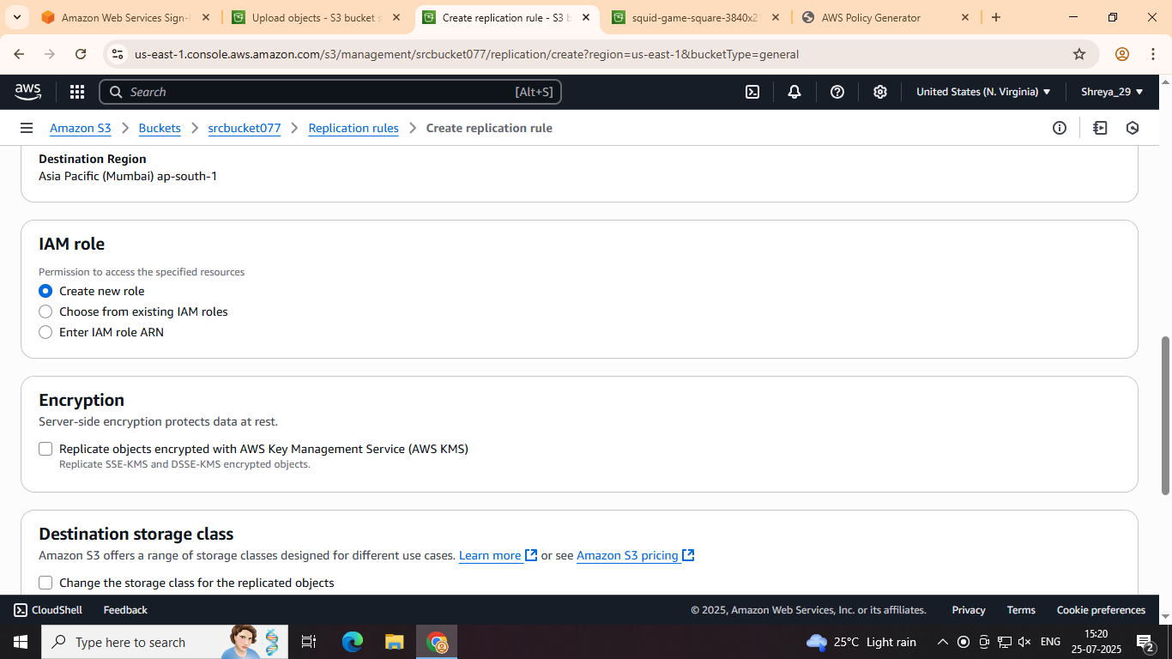
  - AWS will create the necessary IAM role for you automatically. You can view the role under IAM > Roles if you want to inspect the permissions
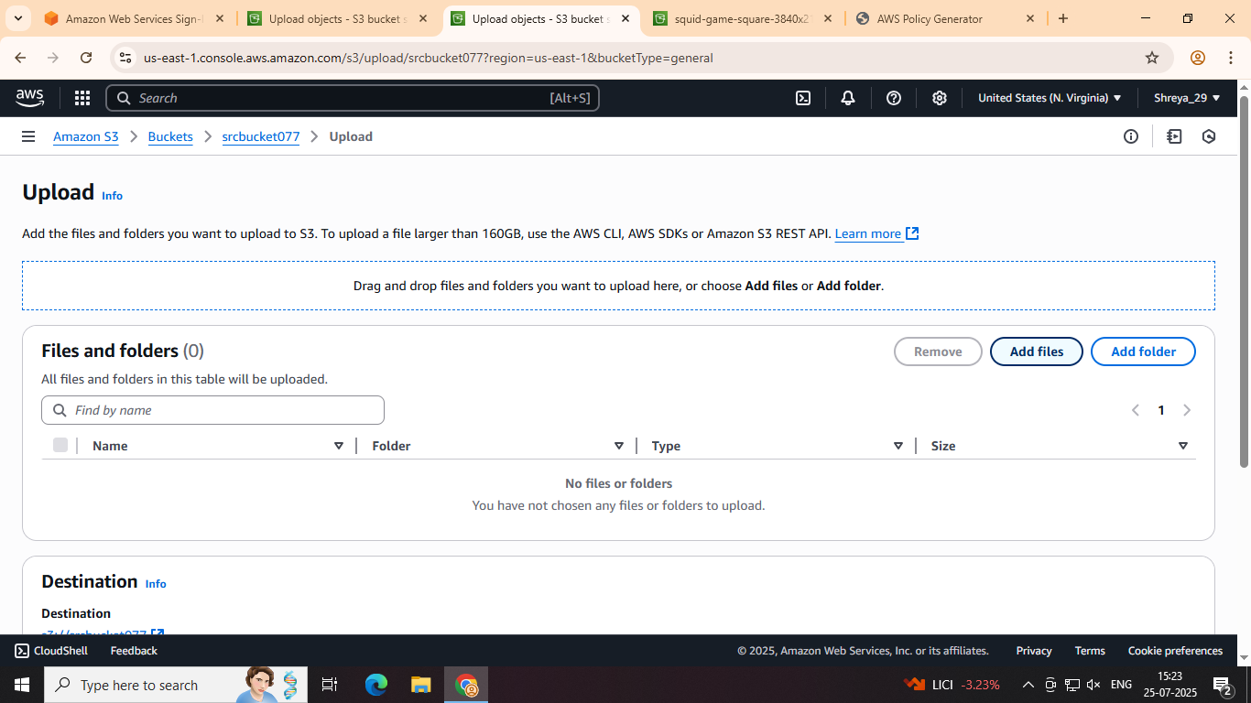
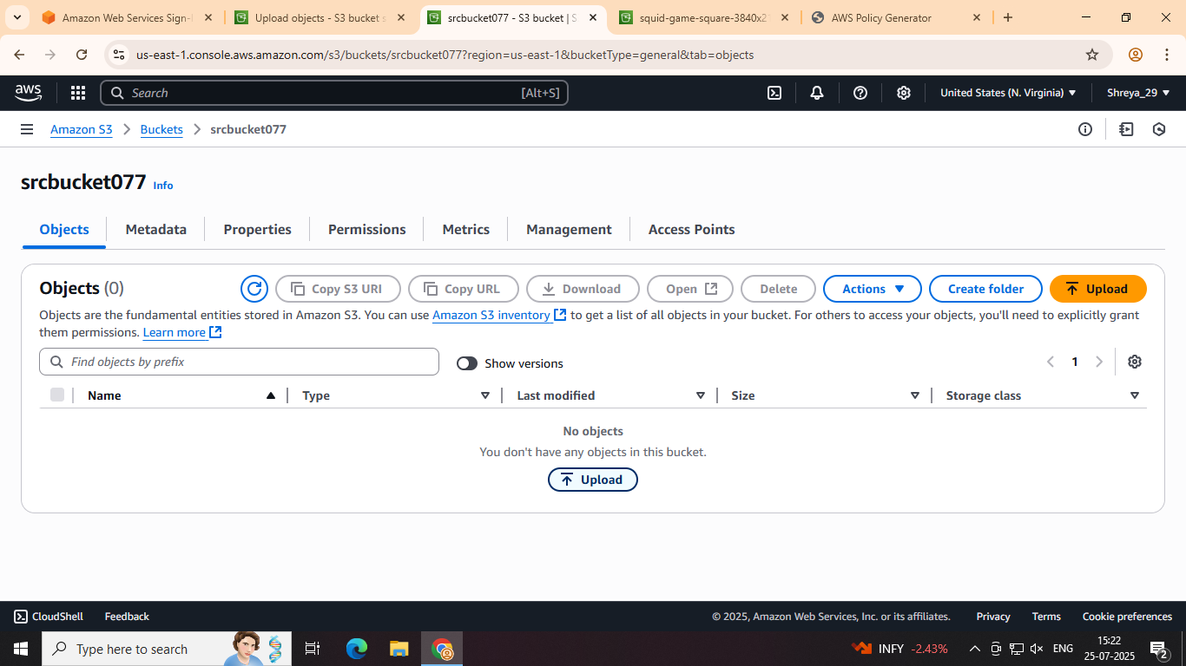
Step 4: Upload Files to the Source Bucket
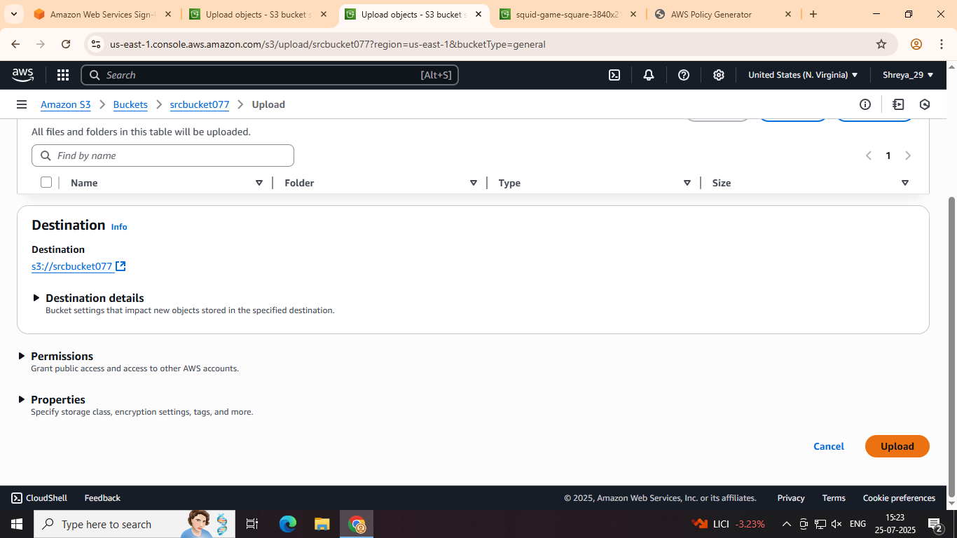

Step 6: Test Replication with New and Updated Files
- Upload More Files:
  - Upload additional files to the source bucket and check if they are replicated to the destination bucket.
- Modify an Existing File:
  - Modify or replace an existing file in the source bucket.
  - The modified version should also replicate to the destination bucket.
